Civil Engineering Insight Studio

1. INTRODUCTION
1.1 Project Overview
Civil Engineering Insight Studio is an AI-powered web application developed to analyze construction and structural images and provide professional insights. The system uses advanced vision-language models to interpret uploaded images and generate descriptive and technical information related to civil engineering structures.
The application is built using Streamlit for the frontend and NVIDIA NIM Vision models for backend image processing. It allows users to upload images, analyze them, and maintain a history of reports.

1.2 Purpose
The main purpose of this project is to:
Assist civil engineers in preliminary site inspection.
Provide instant visual analysis using AI.
Reduce manual effort and inspection time.
Maintain digital records of inspections.
Support academic and professional learning.

Team ID : LTVIP2026TMIDS24385
Team Mesmbers :
Pepeti Lakshmana
Peravali Veda Sai
Pidige keerthi
Polukonda Saicharan

2. IDEATION PHASE
2.1 Problem Statement Traditional site inspection in civil engineering requires physical presence, specialized expertise, and significant time for observation, measurement, and documentation. The process heavily depends on manual analysis, which increases the possibility of human errors, inconsistent assessments, and incomplete documentation. Additionally, repeated site visits increase cost and delay decision-making. In modern infrastructure management, there is a growing need for faster, more accurate, and technology-driven solutions. Therefore, there is a need to develop an automated system capable of analyzing structural images and generating reliable technical insights quickly and efficiently, reducing human error, saving time, and improving overall inspection accuracy and documentation quality.
2.2 Empathy Map Canvas
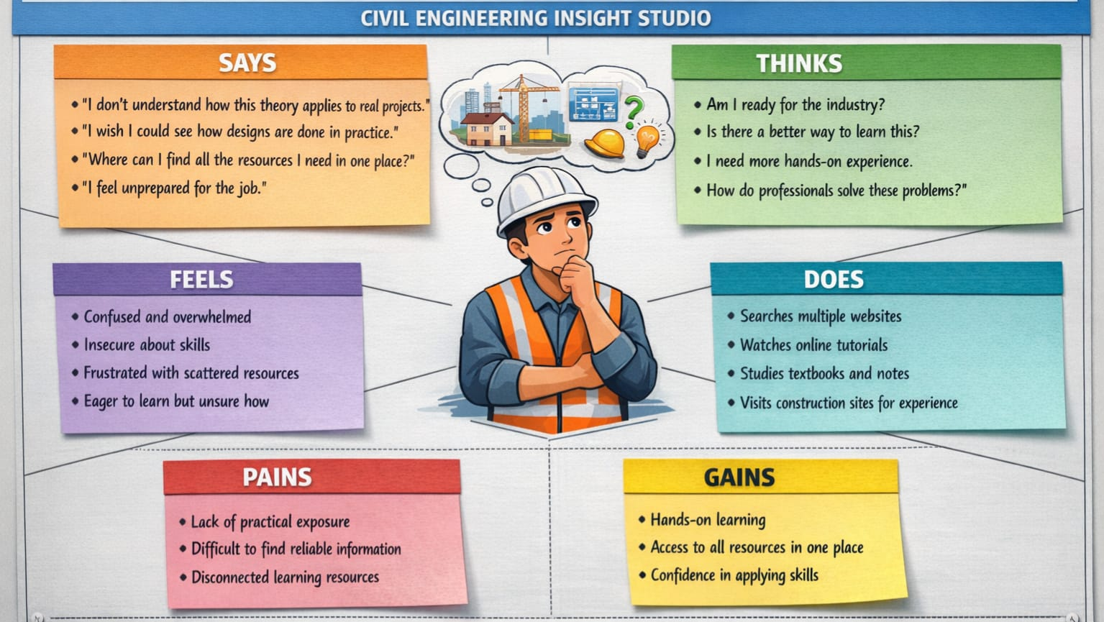
2.3 Brainstorming
During brainstorming, various ideas were discussed:
- Mobile inspection app
- Drone-based monitoring
- AI-based image analyzer
- Automated report generator
- Cloud-based inspection system
- The final idea selected was an AI-based image analysis platform.
3. REQUIREMENT ANALYSIS
3.1 Customer Journey Map
User opens application

Uploads site image

Enters prompt (optional)

Clicks analyze

Receives report

Saves history

Exports PDF
3.2 Solution Requirement
Hardware Requirements
- Computer / Laptop
- Internet connection
Software Requirements
- Python 3.10+
- Streamlit
- NVIDIA API
- Requests Library
- PIL
- Report Lab
3.3 Data Flow Diagram
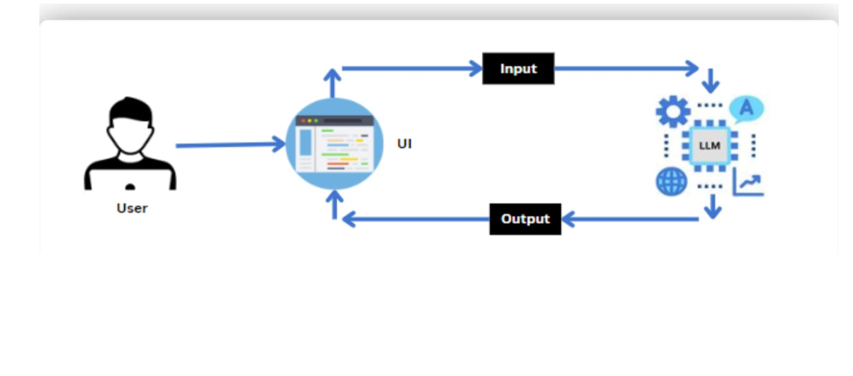
3.4 Technology Stack
Component | Technology
Frontend | Streamlit
Backend | Python
AI Model | NVIDIA NIM Vision
Storage | JSON File
PDF Export | Report Lab
Image Processing | PIL
API | REST API

4. PROJECT DESIGN
4.1 Problem Solution Fit
The proposed solution, Civil Engineering Insight Studio, directly addresses these challenges by introducing an automated image-based structural analysis system. By leveraging image processing and machine learning techniques, the system can analyze structural images, detect defects, and generate technical insights with high accuracy and speed. Automated report generation ensures proper documentation, while centralized data storage improves record management and future comparison.
This solution reduces inspection time, minimizes human error, enhances accuracy, and supports faster, data-driven decision-making. Therefore, the proposed system effectively bridges the gap between traditional manual inspection methods and modern, technology-driven infrastructure assessment practices.
4.2 Proposed Solution
- The system allows users to:
- Upload images
- Send them to AI model
- Receive technical description
- Store reports
- Export reports
- This creates a complete inspection workflow.
4.3 Solution Architecture
User Interface (Streamlit)

Image Processing (PIL)

NVIDIA Vision API

Response Processing

Local Storage (JSON)

PDF Generator

5. PROJECT PLANNING & SCHEDULING
5.1 Project Planning

Phase | Duration
Requirement Analysis | 1 Week
Design | 1 Week
Development | 2 Weeks
Testing | 1 Week
Deployment | 1 Week
Documentation | 1 Week

6. FUNCTIONAL AND PERFORMANCE TESTING
6.1 Performance Testing
Response time: 1-3 minutes
Image upload speed: < 2 seconds
PDF generation: < 3 seconds
Concurrent users: Limited (Local)
Testing confirmed stable performance.
7. RESULTS
Home Screen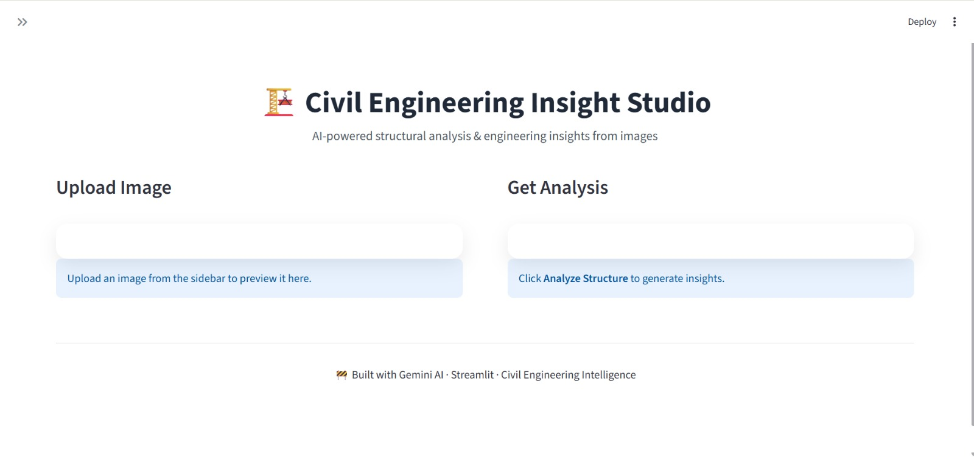

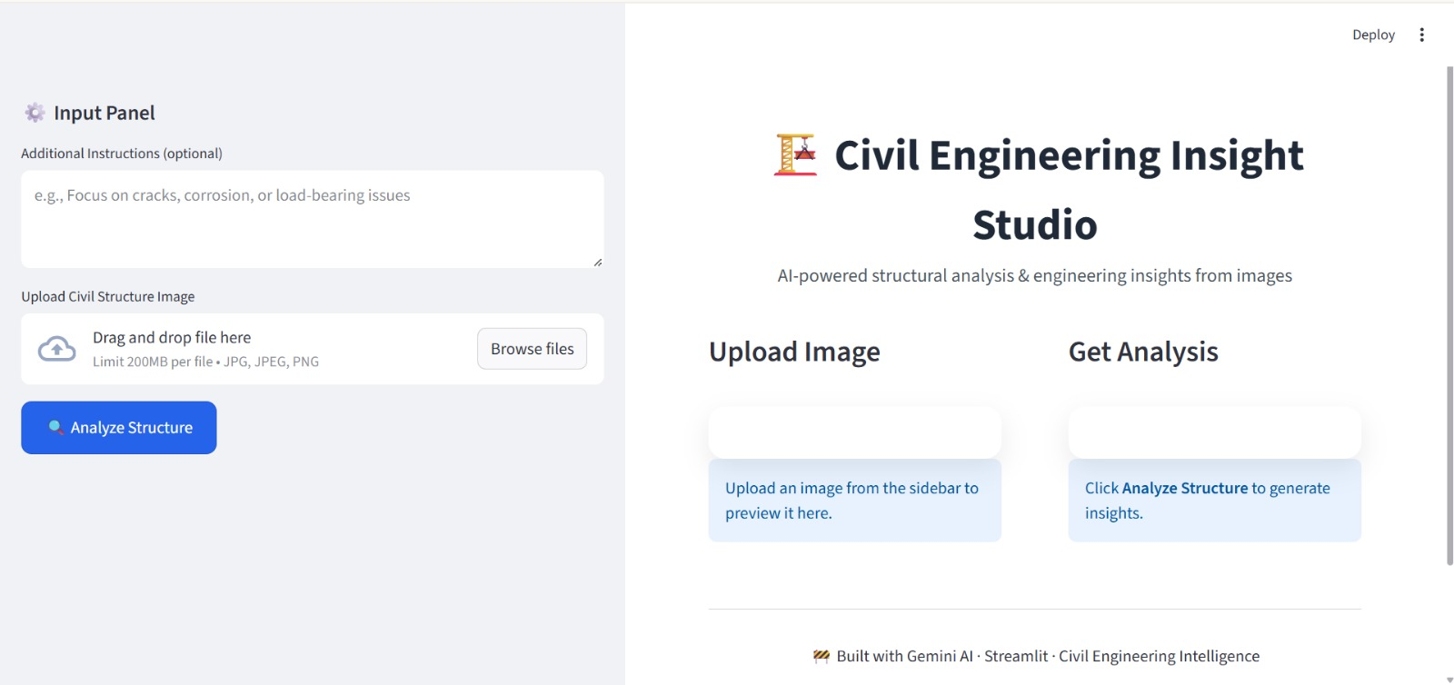
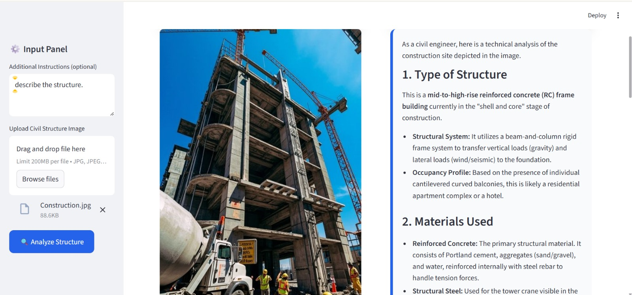

8. ADVANTAGES & DISADVANTAGES
Advantages :
- Fast inspection
- Easy to use
- Automated reports
- Low cost
- Portable system
- Digital records
- Disadvantages
- Requires internet
- Depends on AI accuracy
- Limited free API usage
- No physical verification
9. CONCLUSION
In conclusion, the development of Civil Engineering Insight Studio presents a modern and efficient solution to the challenges associated with traditional structural inspection methods.
Manual site inspections are time-intensive, require expert involvement, and are susceptible to human error and inconsistent documentation. The proposed system overcomes these limitations by integrating automated image analysis and intelligent processing techniques to evaluate structural conditions quickly and accurately. By enabling real-time insights, systematic documentation, and improved data management, the platform enhances decision-making and reduces inspection delays and costs. The successful implementation of this project demonstrates the potential of technology-driven approaches in transforming civil engineering practices, improving infrastructure monitoring, and promoting safer, more reliable structural assessment methods.
10. FUTURE SCOPE
Future enhancements include:
- Mobile application
- Multi-user login
- Cloud database
- Drone integration
- Real-time video analysis
- BIM integration
- IOT sensor data integration
11. APPENDIX
Software Libraries
Streamlit
Requests
PIL
Report Lab
dotenv
API
NVIDIA NIM API
References
NVIDIA AI Documentation
Streamlit Documentation
Python Documentation

Demo Video:
https://drive.google.com/file/d/1xycuE7NWqH5r31CJ3p5T3VvxaTW6w8lD/view?usp=sharing

GitHub Link:
https://github.com/Pepetilakshmana/Civil-Engineering-Insight-Studio

Bskn

